# Submarine Research

## How do Submarines work?

A submarine can float on the surface of the sea or ocean etc due to the weight of the water when displaced by the submarine is equal to the weight of the submarine itself. The displacement of water creates a force called buoyant force and is the opposite force to gravity which will pull the submarine down.

To control the buoyancy the submarine has ballast tanks and some trim tanks which can be filled with water or air. When a submarine surfaces these tanks are filled up causing the submarines density to be less than the surrounding water. When the submarine dives into the water the tanks are then filled with water and the air is vented out causing the density of the submarine to be greater than the surrounding water so it begins to sink.

A supply of compressed air stays aboard the submarine in air flasks for life support and for the ballast tanks. Submarines also have sets of what looks like short wings called hydroplanes at the back/ stern of the submarine to help control the dive. They are angled so water can easily move over it which forces it to angle upwards making it easier to dive downward.

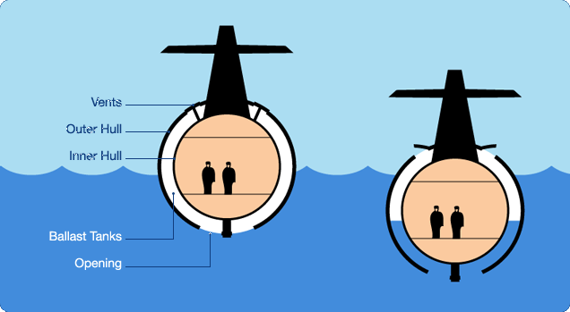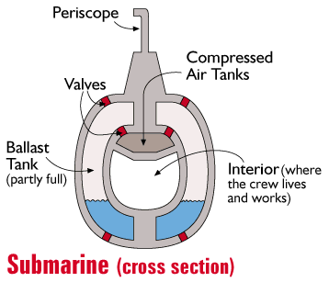

## Types of Submarine and Weaponry

Submarines are based into four different categories and they are Ballistic Missile, Guided Missile and Hunter/ Attack and Deep Submergence Rescue.

### Attack/ Hunter

The Attack/ Hunter Submarine are used to seek and destroy enemy submarines and ships. They carry tomahawk cruise missiles and Special Forces aboard such as navy seals. They are usually tasked with Intelligence, Surveillance and Reconnaissance (ISR) missions, support battle operations and fight in sea mine warfare. Image is shown below.

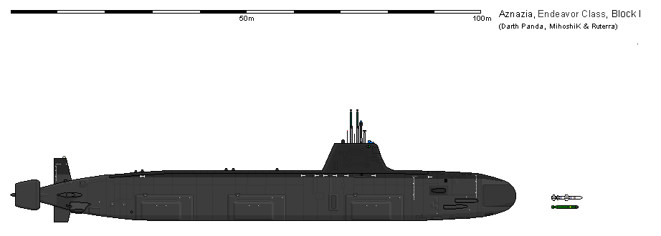

### Ballistic Missile

The Ballistic Missile Submarines also known as Boomers are undetectable launch platform for intercontinental missiles. They are designed especially for stealth and the delivery of nuclear warheads. Most of the submarines carry up to 20 submarine based missiles some being independently targeted warheads. Image shown below

### Guided Missile

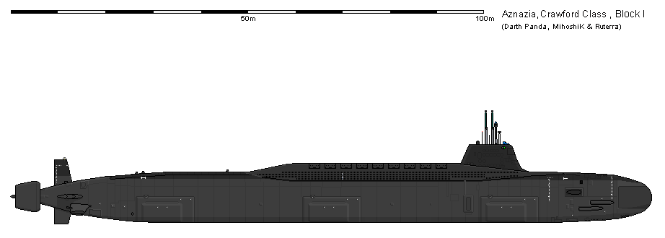The Guided Missile Submarines are unprecedented strike and special operation mission capabilities from a stealthy platform. They have tactical missiles and equipped with communications capabilities, they are also capable of directly supporting Special Operation Forces.

### Deep Submergence Rescue

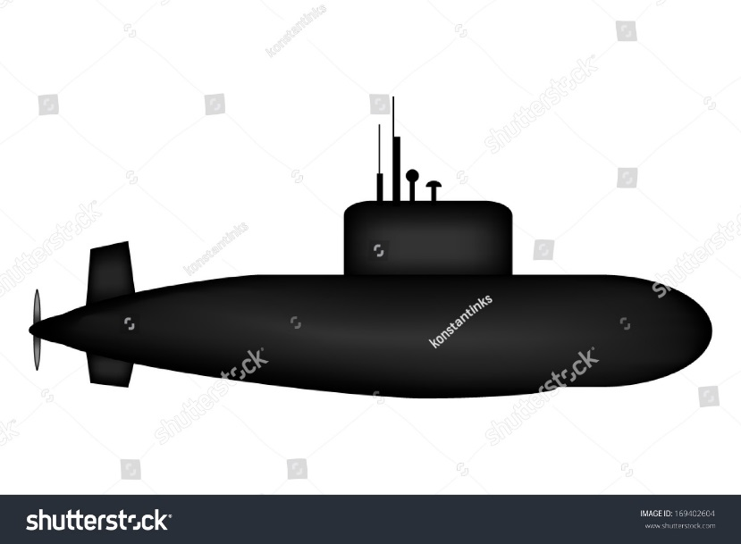When trouble happens beneath the waves these Submarines are the ones to call. They perform underwater rescue operations on disabled submarines. They’re designed for quick deployment in the event of a submarine accident transportable by truck, aircraft, ship or specially configured attack submarine.